Dice Game Results Lost and Found

Team Results:
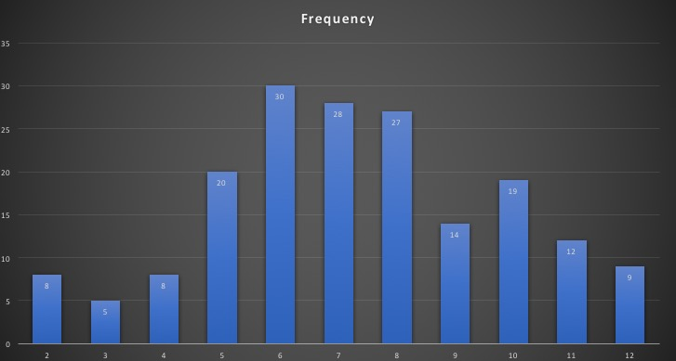
Low on edges, rises towards middle.

Most Similar:
Nick and Maddie
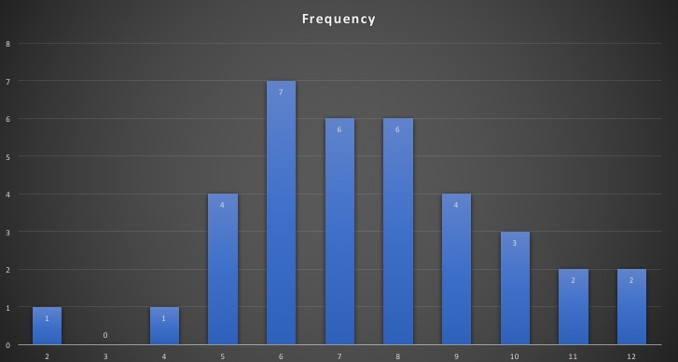
Low on edges, rises near middle. Similar to bell curve.

Most Different:
Pablo and Haley
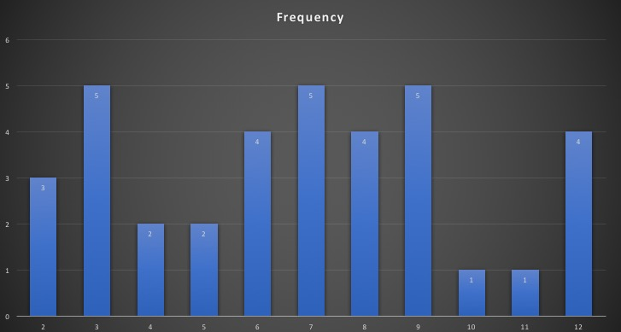

Peaks on edges, dips near middle. Only group to have rolled 3’s.

